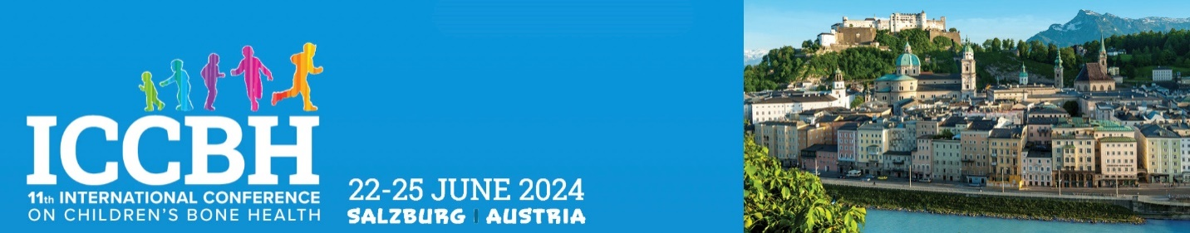

NEW INVESTIGATOR AWARD - CONFIRMATION OF ELIGIBILITY

To be completed and uploaded during submission or email to events@theiscbh.org after submission

Application details

Name:
Email:
Abstract Title:

Eligibility criteria

To be eligible an author must be:
- First and presenting author
- Must be in training or within 5 years of attaining PhD or MD or equivalent

If you do not fit the above criteria, however, consider that you are eligible due to extenuating circumstances, please advise below why you feel you should be considered:

I confirm that the applicant meets the above criteria and that (s)he holds the following post in my department:

Post held by author:
Head of Department Name:
Head of Department Email:
Signature:
Date:

Please upload to the submission portal during abstract submission.

