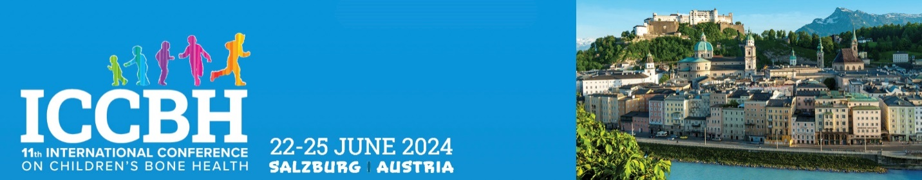

REDUCED REGISTRATION FEE - CONFIRMATION OF ELIGIBILITY

To be completed and emailed to events@theiscbh.org within two weeks of registration.

Applicant details

Name:
Email:

Eligibility criteria

To be eligible for the reduced fee a delegate must be one of the following:

- Student (PhD students, undergraduates)
- Junior Post Docs (within 5 years of PhD)
- Resident or Fellow
- Allied Health Professional
- Patient Organisation Representative

I confirm that the applicant meets one of the above criteria (please tick the appropriate role) and that (s)he holds the following post in my department:

Post held by delegate:
Head of Department Name:
Head of Department Email:
Signature:
Date:

Please email this completed form to the ICCBH 2024 events team
events@theiscbh.org

